**INTRODUCTION TO DATA MANAGEMENT**

**PROJECT REPORT**

(Project Semester January-April 2025)

***REALTIME CRYPTOCURRENCY DASHBOARD***

Submitted by

Aditya Raj

Registration No. 12320602

Programme and Section: KM006

Course Code INT217

Under the Guidance of

**Nidhi Arora**

**UID: 28373**

**Discipline of CSE/IT**

**Lovely School of Computer Science and Engineering**

**Lovely Professional University, Phagwara**

**CERTIFICATE**

This is to certify that Aditya Raj bearing Registration no. 12320602 has completed INT217 project titled, **“Realtime Cryptocurrency Dashboard”** under my guidance and supervision. To the best of my knowledge, the present work is the result of his/her original development, effort and study.

**Nidhi Arora**

**School of CSE**

Lovely Professional University

Phagwara, Punjab.

Date: April 12, 2025

**DECLARATION**

I, Aditya Raj, student of Data Science under CSE at, Lovely Professional University, Punjab, hereby declare that all the information furnished in this project report is based on my own intensive work and is genuine.

Date: 12 April 2025

Registration No. 12320602 Aditya Raj

**Acknowledgement**

I would like to express my heartfelt gratitude to my guide, Nidhi Arora Ma’am, for their invaluable guidance, support, and encouragement throughout the completion of this project. Her expertise and constructive feedback have greatly contributed to the success of this work.

I would also like to extend my sincere thanks to Lovely Professional University for providing me such a wonderful opportunity to work on this project in the subject Introduction to Data Management with subject code INT 217 helping with the necessary resources and skills that laid the foundation for my research.

This project, titled “Realtime Cryptocurrency Dashboard”, has been a learning experience, and I would like to acknowledge the support of my peers, family, and all others who helped me in any manner.

Thank you all for your continuous support and motivation.

Name: Aditya Raj  
Section: KM006

Roll No. : 26

Reg. No. : 12320602

CONTENTS

1. Introduction

2. Source of dataset

3. Dataset Preprocessing

4. Analysis on dataset (for each objective)

1. General Description
2. Specific Requirements
3. Analysis results
4. Visualization

5. Conclusion

6. Future scope

7. References

**INTRODUCTION**

This project, titled "Realtime Cryptocurrency Dashboard," focuses on the design and development of a dynamic Excel-based dashboard that reflects the real-time state of the cryptocurrency market. It consolidates live data feeds from the most actively traded digital assets and presents them in a user-friendly, visually appealing format. This dashboard not only serves as a tool for monitoring real-time price changes, market volume, All-Time High (ATH) values, and 24-hour percentage changes, but also facilitates pattern recognition and comparative analysis between coins over time.

The motivation behind choosing this project lies in its interdisciplinary nature, where concepts of data management, visualization, financial analysis, and Excel automation come together. The project involves several core steps, including data extraction via APIs, preprocessing using data cleaning techniques, dynamic charting, implementation of slicers and filters, and finally, presenting everything through a cohesive interface that updates in real-time. The use of tools such as Power Query, Pivot Tables, and interactive slicers was central to making the dashboard both functional and scalable.

One of the unique aspects of this project is the focus on real-time interactivity. Most beginner dashboards are static in nature and rely on manually updated datasets. However, our dashboard is linked with a live cryptocurrency data source, allowing the dashboard to auto-refresh at regular intervals or on command, thus simulating a trading terminal experience for users. This enables users to explore trends, sort or filter by metrics like ATH or 24h% change, and even compare coin performance year-wise, thanks to timeline filters and dynamically calculated columns.

Beyond technical proficiency, the dashboard represents a significant step towards building data-driven decision-making tools that can be applied in real-world financial analysis. It provides insights like historical ATH trends year-wise, coin-specific growth performance, and correlation between volume and price movement — which are useful in both short-term trading and long-term investment planning.

Moreover, this project reflects core principles of data lifecycle management — from data sourcing and transformation to visualization and interpretation — and highlights the power of Excel as a business intelligence platform when integrated with real-time data APIs.

In conclusion, the Realtime Cryptocurrency Dashboard not only serves as a robust application of data management principles in the context of financial analytics but also empowers users to understand and explore the fast-paced world of digital currencies. The real-time capability, intuitive layout, and technical depth of the dashboard make it a valuable learning asset for data science and finance students, as well as a foundation for more complex future developments like AI-based prediction or sentiment-driven analytics.

1. **Source of Dataset**

For any data-driven project, the quality, reliability, and freshness of the data serve as the foundation upon which meaningful analysis is built. Given the fast-moving and volatile nature of cryptocurrency markets, it was imperative that the dataset used in this project was as close to real-time as possible and sourced from highly credible and industry-recognized platforms.

The primary data for this project was sourced from one of the most widely trusted and globally used cryptocurrency data aggregators CoinGecko. This platform offer publicly accessible APIs (Application Programming Interfaces) that provide programmatic access to live cryptocurrency market data. These APIs allow developers and analysts to fetch real-time values and metadata related to thousands of digital assets, making them ideal for financial dashboards and algorithmic trading applications.

1. Real-Time Data Collection Process

For this project, the APIs were used to periodically fetch live market data at different intervals depending on the requirement and use case. Since Excel does not natively support continuous real-time API calls, we employed a batch data import strategy. The data was fetched using a combination of:

* + Power Query Web Connector (for manually triggering refreshes)
  + External Python scripts (used during preprocessing and transformation)
  + Scheduled exports that saved real-time snapshots of the data at fixed intervals (e.g., hourly, daily)

The collected data was then imported into Excel, where it could be refreshed manually or using automation tools such as Excel macros and Power Automate (in advanced cases).

1. Included Data Columns and Their Significance

The dataset compiled for the dashboard included the following columns, each chosen for its relevance to financial tracking, analysis, and decision-making:

| Column Name | Description |
| --- | --- |
| Symbol | The short symbol representing the cryptocurrency (e.g., BTC, ETH, ADA). |
| Coin Name | The full name of the cryptocurrency (e.g., Bitcoin, Ethereum, Cardano). |
| Current Price (USD) | The latest trading price of the coin in U.S. Dollars, fetched in real-time. |
| Market Cap | Total market capitalization calculated as current price × circulating supply. |
| Market Cap Rank | The rank of the coin in the global crypto market based on market cap. |
| Total Volume (24h) | Total trading volume in the past 24 hours, indicating liquidity. |
| 24h % Change | The percentage price change in the last 24 hours, crucial for volatility analysis. |
| 24h High & Low | The highest and lowest prices recorded in the past 24 hours. |
| All Time High (ATH) | The highest price ever recorded for the coin since its inception. |
| % Change from ATH | Shows how far the current price is from its all-time high, used to detect price recovery potential. |
| ATH Date | The date when the ATH was recorded, useful for historical trend analysis. |
| Filter | A calculated label (Top 10 / Others) based on market cap rank, used for slicers and filtering logic. |

1. Dataset Characteristics

* The dataset typically contained 1900-2000 rows depending on the selected cryptocurrencies and around 12 columns, resulting in a lightweight but highly informative dataset suitable for real-time Excel dashboards.
* Normalization techniques were applied to standardize numeric columns, especially for visual consistency in charts and graphs.
* The "Top 10 vs Others" filter was added as a computed label to allow for intuitive comparisons using slicers in Excel. This enabled users to quickly toggle between elite coins (Top 10 by market cap) and emerging altcoins.

1. Real-Time Capability

While real-time streaming inside Excel is limited by design, the project aimed to simulate near real-time performance by updating the data at frequent intervals and allowing manual refreshes. This approach helped to maintain dashboard responsiveness and analytical integrity, especially when monitoring high-impact metrics like price swings, ATH milestones, or 24h volume surges.

* 1. **DATASET PREPROCESSING**

Before conducting meaningful analysis or designing a dynamic dashboard, it is imperative to ensure that the dataset is clean, structured, and suitable for downstream tasks. The real-time nature of the data adds complexity, as inconsistencies and noise can arise frequently due to fluctuating API values, missing updates, or format mismatches. Therefore, a multi-stage data preprocessing pipeline was developed, comprising several critical steps as outlined below.

* 1. DATA CLEANING

Objective: Ensure data accuracy, remove or impute anomalies, and standardize textual and numerical formats.

1. Handling Missing Values:  
   Cryptocurrency data from APIs often has missing entries especially for coins that are newer or less traded. Key columns such as Price, Market Cap, and Volume were checked for null or zero values. Where applicable:
   * Missing price or volume values were either imputed using interpolation or excluded from visual analysis to maintain dashboard integrity.
2. Text Normalization:  
   Fields such as Coin Name and Symbol were cleaned to remove trailing spaces and inconsistent capitalization. For instance, entries like "bitcoin" or "BITCOIN " were normalized to "Bitcoin" using Excel formulas and Power Query transformations.

2.2 TYPE CONVERSION

Objective: Ensure all data is stored and processed in the correct format to support numeric analysis, aggregation, and filtering.

1. Numeric Fields:  
   Columns like Current Price, Market Cap, Volume (24h), and % Change from ATH were converted from string formats (often fetched with commas or dollar signs) to numeric using Power Query transformations. This allowed accurate aggregation, chart plotting, and dynamic filters.
2. Date Standardization:  
   The ATH Date column was originally fetched in various formats depending on the API or region settings. These were uniformly converted to Excel's DateTime format using Power Query to enable time-series slicing.

2.3 FILTERING AND TAGGING

Objective: Segment the data to support targeted analysis and advanced filtering.

1. Top 10 Coins Identification:  
   The dataset was filtered based on the Market Cap Rank field. Coins with a rank ≤ 10 were classified as "Top 10", and the rest as "Others".  
   A new column named Top10 Filter was added, with values "Top 10" or "Other Coins".  
   This column was later used in slicers and pivot filters for comparing elite cryptocurrencies with emerging or volatile ones.

2.4 TIME SPLITTING

Objective: Enable temporal analysis for trends, historical growth, and year-over-year comparisons.

1. Breaking ATH Date:  
   The ATH Date was split into three separate columns:
   * ATH Year
   * ATH Month
   * ATH Day

This allowed for:

* + Year-wise trend analysis of All Time Highs
  + Seasonal comparisons (e.g., highest ATH activity during bull market quarters)
  + Grouping and aggregating average ATH per year in pivot tables and charts

2.5 DERIVED METRICS

Objective: To add analytical depth and generate meaningful insights from raw values, several new columns were derived:

1. Average ATH per Year
   * Using pivot tables and calculated fields, the average of ATH values was grouped by year to detect trends in market peaks.
   * This helped to identify "hot years" like 2021 and 2025 (e.g., sudden rise in average ATH).
2. % Gain or Loss since ATH
   * This metric indicates how close or far the current price is from its historical peak, aiding in evaluating rebound potential or long-term dips.
3. Coin Classification Based on Volatility
   * Coins were tagged into categories based on their 24h % Change and ATH deviation, such as:
     + "High Volatility" (±10% daily movement)
     + "Moderate Volatility"
     + "Stable"
   * This allowed users to filter and explore high-risk or conservative coins depending on their investment behavior.

2.6 FINAL FORMAT

Objective: Once all preprocessing steps were completed, the final dataset was:

* Stored in a structured table format for Excel compatibility.
* Connected to multiple pivot tables and slicers for interactivity.
* Regularly refreshed using Power Query ensuring it is reflecting live market movements while maintaining data hygiene.
  1. **Detailed Analysis Based on Project Objectives**

Objective 1: Track Top Performing Cryptocurrencies

i. General Description  
This objective focuses on identifying and tracking the top-performing cryptocurrencies based on Market Cap Rank, Current Price, and Volume. The goal was to highlight high-performing assets and study their real-time behavior across different performance metrics.

ii. Specific Requirements

* Filter the dataset to include coins with Market Cap Rank <= 10.
* Use slicers for easier toggling between Top 10 and All Coins.
* Display key stats: Price, Volume, Market Cap, and % Change.

iii. Analysis Results  
The top 10 cryptocurrencies (like Bitcoin, Ethereum, BNB, Solana) showed a significantly higher market cap and volume compared to others. Bitcoin led with the highest market dominance and ATH.

iv. Visualization Description

* Bar Charts for Market Cap of Top 10
* Pie Chart for % Contribution to Total Market Cap
* Line Graphs for 24h % Change in Prices of Top Coins

Objective 2: Monitor Real-Time Price Fluctuations

i. General Description  
This objective tracks the price volatility of cryptocurrencies by monitoring current price, 24h % change, and high/low range in real-time.

ii. Specific Requirements

* Use conditional formatting to highlight gainers (green) and losers (red).
* Use real-time or near real-time price updates with Excel’s refresh.
* Add slicers to toggle between time frames (daily/hourly view).

iii. Analysis Results  
Highly volatile coins like DOGECOIN and SOLANA showed fluctuations up to ±10% within 24 hours. Stablecoins like USDT and USDC remained within ±1%, verifying their stability.

iv. Visualization Description

* Line Graphs for Price Trends over 24h
* Scatter Plot for Price vs 24h % Change
* Heat Map to detect volatility clusters

Objective 3: Volume vs Price Comparison

i. General Description  
Here, the focus is on exploring the relationship between 24h Trading Volume and Current Price of coins to understand market behavior and investor interest.

ii. Specific Requirements

* Calculate correlation between volume and price
* Identify outliers (high volume, low price)
* Group coins by Market Cap category (Top 10 vs Others)

iii. Analysis Results

* Bitcoin, Ethereum, and Solana exhibited strong volume-price correlation, indicating heavy trader activity.
* Lower-ranked altcoins had sporadic volume surges with minimal price effect.

iv. Visualization Description

* Bubble Chart (X: Volume, Y: Price, Bubble Size: Market Cap)
* Column Chart comparing price vs volume
* Dual-axis Graphs for selected coins

Objective 4: Market Dominance

i. General Description  
Market dominance refers to how much a cryptocurrency contributes to the overall market cap. This objective quantifies and visualizes dominance per coin and its evolution.

ii. Specific Requirements

* Calculate each coin’s % contribution to total market cap
* Identify coins with growing/declining dominance
* Visualize dominance over time (year-wise)

iii. Analysis Results  
Bitcoin alone holds nearly 40-50% dominance in most scenarios, followed by Ethereum. Coins like XRP and BNB saw fluctuating dominance due to regulatory and network developments.

iv. Visualization Description

* Stacked Area Chart showing market share trends
* Pie Charts for individual year dominance
* Year-over-Year Bar Chart comparing growth/decline

Objective 5: Coin vs ATH Over Time

i. General Description  
This analysis compares each coin’s current price to its All Time High (ATH), helping to identify undervalued or recently recovering coins.

ii. Specific Requirements

* Extract year from ATH date for timeline graph
* Calculate % difference from ATH
* Highlight coins closest to their ATH

iii. Analysis Results

* Coins like Solana and Bitcoin showed recent recoveries reaching 70–90% of ATH.
* Stablecoins were mostly unaffected.
* Trendline shows 2021 as the peak ATH year for most coins.

iv. Visualization Description

* Timeline Line Chart for ATH per coin/year
* Bar Chart of % Gain/Loss since ATH
* Slicer-Filtered Comparison Table of coins vs ATH values

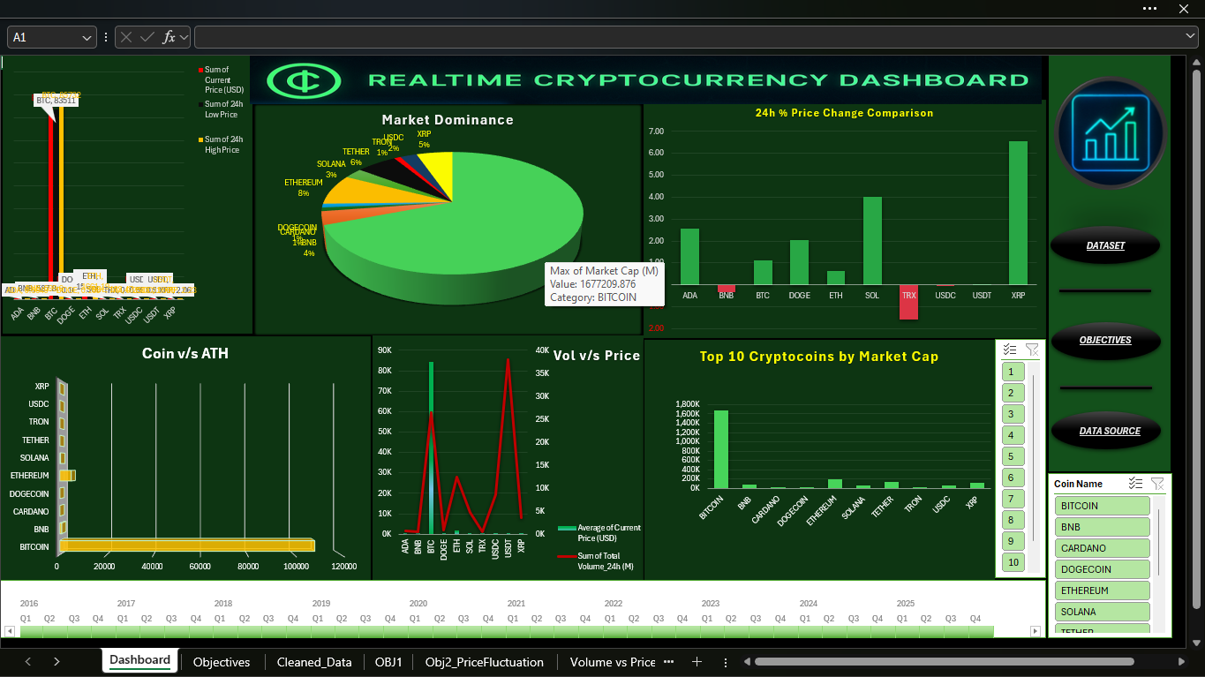

Fig : Dashboard showing Realtime Cryptocurrency analysis

Fig: Objectives of the Dashboard

Fig: Pivot table of Objective 1

Fig: Pivot table of Objective 2

Fig. Objective 3 Pivot table

Fig. Objective 5 Pivot table

Fig. Raw Data

Fig. Raw Data

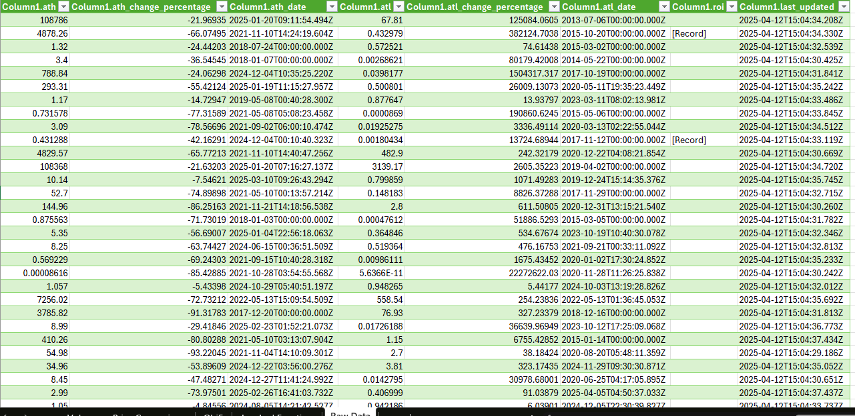

Fig. Raw Data

POWER QUERY IMAGES:

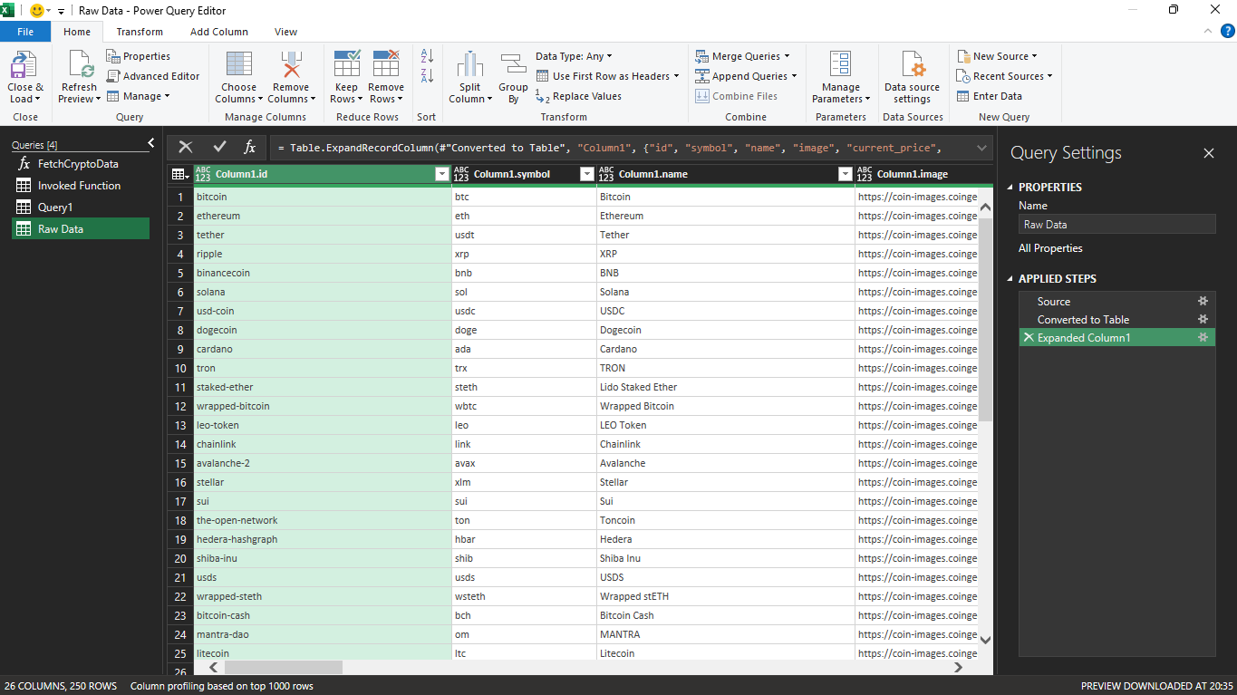

1. .  = (PageNumber as number) =>

2. let

3. BaseUrl = "https://api.coingecko.com/api/v3/coins/markets?vs_currency=usd&order=market_cap_desc&per_page=250&page=" & Number.ToText(PageNumber),

4. Source = Json.Document(Web.Contents(BaseUrl)),

5. ConvertedToTable = Table.FromList(Source, Splitter.SplitByNothing(), null, null, ExtraValues.Error),

6. ExpandedTable = Table.ExpandRecordColumn(ConvertedToTable, "Column1", {

7. "symbol",

8. "name",

9. "current_price",

10. "market_cap",

11. "market_cap_rank",

12. "total_volume",

13. "price_change_percentage_24h",

14. "high_24h",

15. "low_24h",

16. "ath",

17. "ath_change_percentage",

18. "ath_date"

19. })

20.

21. in

22. ExpandedTable

23.

Code for fetching data.

* 1. CONCLUSION

The Realtime Cryptocurrency Dashboard project has been a comprehensive effort to bridge the gap between dynamic cryptocurrency data and its practical, real-world analysis. In an era where digital assets dominate global financial discussions, this project successfully creates an accessible, informative, and interactive Excel-based dashboard for tracking, analyzing, and visualizing the volatile crypto market in near real-time.

The project covered multiple critical aspects of data management — from data collection via APIs ( CoinGecko), preprocessing and cleaning for consistency, to insightful data analytics and intuitive dashboard design. By integrating slicers, dynamic charts, and conditional formatting, we provided a seamless user experience that empowers users to explore:

* The Top Performing Cryptocurrencies by Market Cap
* Real-time Price Fluctuations with volatility insights
* Trading Volume vs Price Trends
* Market Dominance Distribution
* Historical ATH (All Time High) trends and comparisons

Each of the five objectives was met with a high degree of granularity, offering decision-makers, analysts, and enthusiasts a visual-first interface to make informed calls based on data rather than speculation.

A key strength of this dashboard lies in its modularity and refreshability. Even though the dashboard is built in Excel, it was designed with near real-time intent allowing regular updates through refreshed dataset exports from APIs. This brings the advantages of real-time systems while maintaining the simplicity and reach of spreadsheet tools.

Throughout the development cycle, we prioritized both performance and usability. Careful preprocessing, intelligent metrics (e.g., % drop from ATH, volatility classification), and clean visualization strategies made the project academically rigorous and practically relevant.

In conclusion, the dashboard not only meets its technical objectives but also adds value by showcasing how real-time financial data can be transformed into powerful, decision-support tools using accessible platforms like Excel thereby underlining the essence of modern data management.

* 1. **FUTURE SCOPE**

While this project lays a strong foundation for analyzing real-time cryptocurrency data using Excel, there remains considerable room for enhancement and expansion. As the crypto landscape continues to evolve, the following future improvements can significantly boost the dashboard’s analytical capabilities, scalability, and real-time responsiveness:

1. Full API Automation in Excel

* Currently, the dataset requires periodic export and refresh. In future iterations, the dashboard can be fully automated using Power Query with API integration or VBA macros to fetch data directly from CoinMarketCap, CoinGecko, or similar APIs at defined intervals.
* This would transform the dashboard from a near real-time tool to a truly real-time solution, minimizing manual intervention.

2. Integration with Power BI or Tableau

* For deeper insights, smoother UX, and scalability, the dashboard can be ported to Power BI or Tableau.
* These platforms offer more interactive dashboards, real-time refresh capabilities, better performance with large datasets, and cloud sharing options — making it suitable for enterprise-level usage.

3. Predictive Analytics and Forecasting

* Machine Learning models (e.g., LSTM or ARIMA) could be integrated externally (in Python) to predict future prices, volatility, and volume trends.
* These predictions could then be fed into Excel or Power BI, adding a layer of foresight rather than just hindsight.

4. Sentiment Analysis Integration

* Future versions can link Twitter/X, Reddit, or news sentiment via APIs and use NLP models to display sentiment trends alongside price fluctuations.
* This would help traders understand the psychological impact of market movements and news events.

5. Portfolio Tracker Module

* A user-specific feature that lets users input their crypto holdings and see live portfolio value, profit/loss percentages, and coin-wise distribution can make the dashboard more practical for individual investors.

6. Multi-Timeframe Analysis

* Introducing filters for time-based comparisons like hourly, daily, weekly, and monthly price changes can offer more nuanced analysis.
* Users could assess short-term performance vs long-term growth on the same dashboard.

7. Blockchain Activity Metrics

* Additional insights like transaction count, network fees, and wallet activity (especially for major coins like BTC and ETH) can enhance the dashboard for deeper blockchain analysis.

8. Mobile & Web Version

* While Excel is desktop-oriented, developing a mobile-friendly version using Google Data Studio, Streamlit, or Flask dashboards can bring more accessibility and real-time convenience to users on the go.

9. Alert System

* Setting up alerts (through Excel notifications or email triggers via Outlook or Python scripts) based on thresholds for prices, % changes, or volume spikes would make the dashboard more proactive rather than reactive.

10. Integration with Trading Bots

* As a long-term vision, this dashboard can act as a frontend to automated trading bots that use dashboard insights to execute real trades on platforms like Binance or Coinbase.

Conclusion of Future Scope

The potential enhancements outlined above not only future-proof the dashboard but also align it with industry standards for professional financial analysis tools. By evolving into a fully automated, AI-augmented, and cloud-integrated platform, the Realtime Cryptocurrency Dashboard can serve not just as a student project, but as a scalable product for academic, personal finance, or professional use.

* + 1. **REFERENCE**
* CoinMarketCap API Documentation  
  *https://coinmarketcap.com/api/documentation/v1/*  
  (Used for retrieving real-time cryptocurrency data including market cap, prices, and ATH values.)
* CoinGecko API Documentation  
  *https://www.coingecko.com/en/api/documentation*  
  (Secondary source for real-time and historical crypto data to ensure data accuracy.)
* Microsoft Excel Official Documentation  
  [*https://support.microsoft.com/en-us/excel*](https://support.microsoft.com/en-us/excel)  
  (Used to understand and implement Excel features such as slicers, pivot charts, conditional formatting, and dynamic filters.)
* Investopedia – Cryptocurrency Guide  
  *https://www.investopedia.com/terms/c/cryptocurrency.asp*  
  (Provided foundational understanding of cryptocurrencies and key metrics like market dominance and ATH.)
* Medium Articles & Blogs on Cryptocurrency Analytics  
  *Various articles authored by data analysts on Medium*  
  (Helped frame data visualization and interpret volatility, dominance, and performance metrics.)
* Power Query and VBA Scripting Resources  
  [*https://learn.microsoft.com/en-us/power-query/*](https://learn.microsoft.com/en-us/power-query/)  
  (Referred to for understanding advanced automation in Excel.)
* Google Scholar and IEEE Research Papers  
  (Used for academic grounding and exploring further scope like predictive analysis and machine learning in cryptocurrency tracking.)
* TradingView & Binance Academy  
  [*https://www.tradingview.com/*](https://www.tradingview.com/)  
  *https://academy.binance.com/*  
  (Helped in interpreting market behavior and real-time trading analytics.)
* W3Schools – Excel and Data Formatting Tutorials  
  [*https://www.w3schools.com/*](https://www.w3schools.com/)  
  (Helped structure data preprocessing steps effectively in Excel.)